**Experiment - 1.3(c)**

**Student Name: Milan Sharma UID: 23MAI10003**

**Branch: ME – CSE - AIML Section/Group: MAI – 1 (A)**

**Semester: 1st Date of Performance: 29 Aug 2023**

**Subject Name: Python Programming Subject Code: 23 CSH 623**

1. **Aim of the Experiment :**

Write a python program to find the sum of first n natural numbers.

1. **Objective of the Experiment :**

To find the sum of first n natural numbers

1. **Algorithm/ Steps for Experiment :**

1.        Declare and initializean array.

2.        The variable sum willbe used to calculate the sum of the elements. Initialize it to 0.

3.        Loop through the arrayand add each element of the array to the variable sum as sum = sum + arr[i].

1. **Code for Experiment :**

arr = [1, 2, 3, 4, 5];

sum = 0;

for i in range(0, len(arr)):

sum = sum + arr[i];

print("Sum of all the elements of an array: " + str(sum));

1. **Result/Output :**

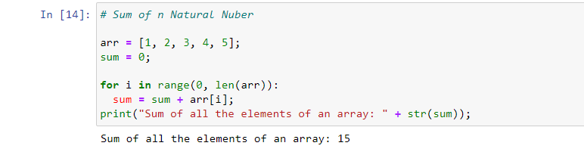

1. **Learning outcomes (What I have learnt):**

1. Learnt the use of range function

2. Learnt the use of len()